The Regional Commission for the Promotion of Tourism
The Regional Commission for the Promotion of Tourism was established by Presidential Decree No. 691 of 1957 and amended by Decree No. 191 of 1959, the
terms of reference of the Regional Commission for the Promotion of Tourism in Alexandria Governorate:
Objecives
- Study of the Territory from a natural and commercial point of view in order to exploit tourism and improve it and
attract tourists to it and make their stay in it attractive and easy.
- The development of a comprehensive assessment of the Territory from the historical and geographic sites as a tool to stimulate tourism in the region.
- Raise the technical level or general tourism awareness of the region.
- Activating tourism and publicity in the region at home and abroad by holding exhibitions, festivals and other means of advertising - whether in leaflets, manuals, publications, newspapers, radio, television and so on.
- The study of the improvement or establishment of machets, springs, mineral water springs and others, which helps to stimulate tourism in the region.
- Proposal to impose fees to stimulate tourism in the region.
- Publication of posters and posters for the landmarks of Alexandria
- Production of tourist videos to show the city's landmarks and tourist elements - Spreading tourist awareness to school students - Reception of official delegations Preparation of tourist visits programs.
The Authority's competences in the field of signboards:
- Expansion of the establishment of signs for the city in both Arabic and English - Signs to urge citizens to preserve the beauty of the city. Activating internal tourism:
- The Authority has a number of tourist establishments that activate the internal tourism movement.
Decision to form the Regional Authority for the Promotion of Tourism:
- The President of the Republic Decree No. 691 of 1975 and amended by Decree No. 191 of 1959 establishing the regional bodies for the promotion of tourism.
A Tourism Authority shall be established in each tourist region of the Republic with a legal personality and the tourist regions shall be determined by the Minister of Tourism.
Body Formation:
It consists of the main members are:
1- Governor ... as president
2- The Director General of the Ministry of Tourism or those appointed by virtue of their functions.
3 - The director of security or the person who appoints him.
4- The Director General of the Customs Department or whoever appoints him.
5- The Director General of the Antiquities Authority or whoever instructs him.
6 - Chairman of the City Council.
In addition to six members representing the following bodies:
Chamber of Commerce in the province - Chamber of the hotel industry - Chamber of the owners of public shops - Chamber of Tourism Industry - Union of Shipping Companies - Union of airlines.
A decision to appoint them shall be issued by the Minister of Tourism. Membership shall be renewed every two years for members not appointed by virtue of their functions.

Plan of the Commission
Department of Tourism Activation

Main activities of the Regional Authority for Tourism Promotion
• Studying all projects that serve the tourism movement and supervise its implementation.
• Participate in celebrations and festivals in the province.
• Preparing the meetings of the Executive Bureau of the Commission and following up the implementation of the recommendations.

Achievements:
• Traffic signs.
• Restoration, maintenance and lighting of Cairo statues.
• Development of Ramses Square.
• Developing the Nile Corniche.
• Participate in the preparations for the maintenance of the Arab sports cycle through the manufacture of a leather portfolio with a map and a booklet for the province of Cairo to give to the participants in the session.
• Participate in the work of the committee formed to supervise the project of street signs, houses and firefronts.
• Participate in the committee formed with regard to the touristic water courses.
• Organizing seminars in the development of tourism awareness among young people and children in youth centers, schools and libraries, in which the employees of the Authority will lecture.

Future Activities:
• Replacing and renewing the Nile fountain in a comprehensive development.
• Development of Cairo tourist fields.

Services provided by the Department of Tourism Activation
• Take the necessary procedures for licensing tourist projects
• Receipt of applications and maps of licenses for tourist projects received from the Licensing Department at the Ministry of Tourism and sent to the competent neighborhood for study in terms of regulatory. In the case of approval, the subject is submitted to the Minister for approval and then returned to the Ministry of Tourism to complete the rest of the licensing procedures for the project.
• Organizing periodic meetings chaired by Dr. Mohieldin, governorate officials and officials of the Ministry of Tourism to overcome the difficulties facing the licensing of some projects.
The Tourism Promotion Authority is responsible for the following:
- Study the region from both natural and commercial in order to exploit tourism and improve it and attract tourists to it and make their stay in it attractive and easy.
- Raise the level of technical and tourist awareness in the province.
- Revitalize tourism and publicity about the region at home and abroad by holding exhibitions, festivals and other means of publicity, whether in local newsletters or radio stations and so on.
The Tourism Promotion Authority is responsible for the following:
- Study the region from both natural and commercial in order to exploit tourism and improve it and attract tourists to it and make their stay in it attractive and easy.
- Raise the level of technical and tourist awareness in the province.
- Revitalize tourism and publicity about the region at home and abroad by holding exhibitions, festivals and other means of publicity, whether in local newsletters or radio stations and so on.
- Study the improvement and establishment of Mashati, summer resorts and mineral water eyes and others, which helps to stimulate tourism in the region

Tourism Development Authority TDA
The TDA is the governmental entity that manages and exploits all lands allocated to establish tourist regions; its main office is in Cairo and it has many branches in other governorates.

Establishment of TDA
Identifying the problems and constraints of tourism development and believing in the role of tourism in supporting the national economy , the State enacted Law No. 7 for the year 1991 in 03/12/1991 concerning certain provisions related to the state property .
In its second article, the law announced the establishment of the Tourism Development authority TDA to undertake the responsibility of managing, exploiting and using lands allocated for tourism development. It also declared the establishment of the General Authority For Reconstruction Projects & Agricultural Development to undertake the responsibility of managing , exploiting and using lands allocated for the purposes of Reclamation and cultivation ,in addition to the establishment of the New Urban Communities Authority to undertake the responsibility of managing , exploiting and using lands allocated for the establishment of new urban communities .
The articles of law No. 7 for the year 1991 focused mainly on assigning the development of desert areas outside the cities cordons (Tourism - Agriculture - Construction) to the aforementioned entities that own the technical base to take responsibility of planning, supervising , implementing, and monitoring development projects.
Presidential resolution of the Arab Republic of Egypt no. 374 for the year 1991 was issued to declare the establishment of the Tourism Development Authority . President of the republic Decided:
- Article one : The Tourism Development Authority TDA is a general economic authority, it has a legal personality, its main headquarter is in Cairo ,it is affiliated to the tourism minister , and may establish more branches in other governorates .
- Article two : The TDA aims to develop tourist areas within the frame of the general policy of the state and its economic plan and in order to achieve its goals , it can engage in all relevant contracts and activities especially :
Activities of TDA
1- Formulating plans of developing tourist areas .
2 - Preparing and reviewing the assessment of projects ,studies and programs necessary for developing tourist areas, in addition to defining priority zones.
3- Implementing main projects of TDA in tourist areas .
4- Collecting of the costs of utilities and services from the beneficiaries against projects carried out by the TDA in tourist areas .
5- Agreeing on Local and foreign loans contracts with commitment to repay.
6- Supervising the tourism development implementation plan in tourist areas.
7- Managing, exploiting and using lands allocated for purposes of the establishment of tourist areas in desert lands.
The prime minister issued decision no. 2908 in 1995 to declare the governing rules of managing , exploiting and using TDA allocated lands.
Also released prime minister resolution no.2908 of year 1995 concerning the regulations and conditions that organized to manage ,exploit and use the allocated lands for tourism development authority .

Objectives
- Relying on the market mechanisms and their interaction in the tourism development process within the framework that meets the main objectives of the social and the economic development plans of the state by supporting tourism business, being the most suitable sector for tourism industry. Gradually limiting the role of the government from the economic competition into a supervising and controlling role that provides the appropriate climate for investment in tourism development.

- Enlarging the social and economic resources of the state by increasing the tourist movement, encouraging investments depending on the tourism potentialities including archeological and historical treasures , natural monuments and unique climate .
- TDA works on varying the products , encouraging the construction of tourist resorts appropriately and supplying infrastructure to serve different tourist patterns as conferences and curative tourism that offer more job opportunities.
- Alleviating burdens on the state's budget to supply infrastructure in the new tourist regions by allowing investors to bear its costs in return for attractive prices and easy regulations for land allocation. TDA also imposes the needed rules to stop land speculation.

- Integrated indicative planning vision is pursued to give the investor( big or beginner) the flexibility and freedom to invest in his selected sites according to his own studies and the type of suggested project. TDA selected sites of development and asked consulting firms to survey them to put plans and to identify the priority zones in new areas in Aqaba, Red sea and South Sinai.

- Adopting flexible policies and supporting them with a balanced promotion and marketing strategy to encourage the private sector to invest more in establishing tourist villages and recreational resorts in the new tourist areas outside city cordons.

Role and tasks of TDA

TDA economical plans
* Managing and exploiting desert lands to establish tourist regions.
* Formulating and supervising the execution of development plans in tourist regions .
* Implementing infrastructure projects in tourist regions with payment of services and utilities costs.
* Agreeing on Local and foreign loans contracts with commitment to repay.
Kinds of TDA projects
- Integrated development / integrated tourism centers ( surface area more than 500.000m2 ).
- Limited development / hotel projects and tourist villages ( surface area less than 500.000m2).
- Tourist services projects.

Achievements of TDA

First: in the field of tourist planning
67 tourist centers are planned distributed on the following tourist areas as follows:
27 / Red Sea
23 / Sinai
7 / El Ain El Sokhna
4 / North Coast
6 / upper egypt
Second : the hotel capacity operating in all regions till now
54,529 hotel rooms / Red Sea
28,604 hotel rooms / Sinai
3,914 hotel rooms / El Ain El Sokhna
1,335 hotel rooms / North Coast
0 hotel rooms / upper egypt
Total opened hotel rooms capacity in TDA 88,382 / hotel room
Third: The Tourist housing capacity operating in all regions till now
8,246 tourist units / Red Sea
20,559 tourist units / Sinai
38,824 tourist units / El Ain El Sokhna
904 tourist units / North Coast
0 tourist units / upper egypt
Total opened tourist units capacity in TDA 68,533 / tourist units
Forth: The Number of Projects for each region till now

395 project / Red Sea
319 project / Sinai
124 project / El Ain El Sokhna
5 project / North Coast
0 project / upper egypt
Total number of tourist projects in TDA 843

Fifth: Certified Area for projects for each region till now
181,534,199 (m2) / Red Sea
68,936,675 (m2) / Sinai
34,352,085 (m2) / El Ain El Sokhna
9,316,502 (m2) / North Coast
0 (m2) / upper egypt
Total Certified Area for projects in TDA 294,139,461 (م2)
Sixth: Further tourist services
- Main and sub roads
- Desalination -sewage treatment- power generation
- Marina an yacht berth
- airport
- Golf coarse

Seventh : the support of development and upgrade in governorates
Infrastructure implementation , development of historic sites and community in tourist areas.

Tourism Development Strategies
To achieve the TDA objectives ,it adopts specific strategy based on the following factors :-

- Limiting the role of the public sector and increasing the role of the private sector
This means transforming the role of the public sector from being the owner and operator into being the planner, the supporter and the facilitator by applying the following :-
1- Introducing modern facilities to steer cooperation between the government and the public sector.
2- Defining the priorities of investment .
3- Offering technical assistance for the private sector.
4- Assessing recommendations according to the master plan.

- Developing the legal and the institutional framework
1- Reviewing and simplifying the legislations, the investment procedures of allocations, contacts and approvals.
2- Setting up the environmental and technical standards of services( water supply, sewage treatment and solid waste disposal).
3- Updating the legislations of tourism development including the administration, the economic, the technical and the environmental aspects.

- Supplying infrastructure in the development areas
One of the main objectives of TDA is to decrease burdens on the State budget of supplying infrastructure in new development areas. Thus, TDA is practically applying the true concept of tourist center where the parent company has to supply infrastructure in all the tourist center and to realize the economic feasibility of such projects.

- Safeguarding the environment
Attaining sustainable development based on environment planning and protecting the natural resources -as the main asset of tourism development- is an important target in the strategy, by applying the following :-
- Providing land use layouts for priority zones to create various tourist patterns in development areas.
- Formulating monitoring and environment assessment programs.

- Defining the priorities of comprehensive development
Priority zones are selected according to the natural characteristics ,the current situation and the possibility of sustainable development in order to achieve the following :-
1- Forecasting a future outlook of tourism development based on analyses of world tourism market , supply and demand, and investment opportunities.
2- Formulating a rational development vision based on selecting priority zones and sites with distinguished nature.
3- Setting the priorities of carrying out including the organizational procedures .
4- Preparing a plan for priority zones based on the investment requirements of infrastructure to push forward investment in these areas.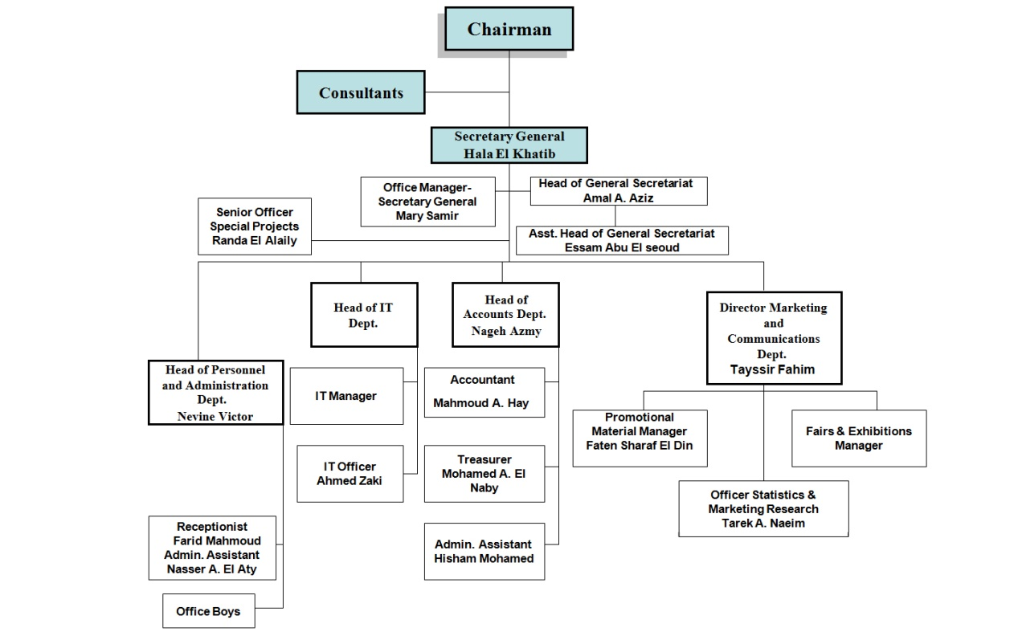

Egyptian Hotel Association EHA

Objectives
- Participating positively in studying and issuing legislations related to hotel industry.
- Promoting tourism marketing plans, as well as assisting hotels in getting their fair share of these plans during International Trade Fairs.
- Establishing a pricing policy with the aim of ensuring a fair market share to all hotels category.
- Preparing detailed feasibility studies to determine investment opportunities in the hotel industry, and defining growth rates and expansion in hotel capacity.
- Playing a more active role in reconciling members when disputes between owning and managing companies, or between hotels and travel agencies, occur.
- Participating in evaluating training programs, and playing an active role in cooperation with the Egyptian Tourism Federation and the Ministry of Tourism in the implementation of these programs
- Establishing and implementing local media plans in order to generate a supportive public opinion towards obstacles and requirements of the hotel industry.
- Solving hotels’ problems that require urgent solutions.

The Chamber of Diving and Watersports
The Chamber of Diving and Watersports was founded by Egypt’s Ministry of Tourism in 2007 with a goal to improve quality, safety and standard of services in the diving and watersports industry, as well as to preserve unique environment of the Red Sea.
All diving centres and safari boats will meet ISO standards EN 14467 / ISO 24803 for diving by 2009 as agreed with Egypt’s CDWS, the Austrian Institute of Norms and the European Underwater Federation.
Diving Centres in Egypt
A Red Sea diving holiday in Egypt is simply unforgettable. Well-established diving centres will gladly provide you with scuba diving information and arrange courses, daily excursions, and live-aboard trips to almost anywhere, from the gigantic coral outcrops of Taba to the vertical walls of Ras Mohammed, from the wrecks of Sha'ab Abu Nuhas to the lonely offshore islands of The Brothers and Zabargad. The Red Sea is dubbed Egypt’s “Garden of Allah”, due to the wealth of underwater pristine life.

The Egyptian Travel Agents Association (ETTA)
The establishment of The Egyptian Travel Agents Association (ETTA) returns to the presidential decree of the president of the Arab republic of Egypt by law No.85 for the year 1968 which charged ETTA with looking after the interests of tourism companies and taking care of them in the scope of the plan tourism of the state and the representation of them in front of the public authorities and the local and International agencies and also helps the authorities and organizations in developing and activating the level of performance
The board of directors which manages the ETTA consists of fifteen members two thirds of them are elected by the general assembly of the chamber and the remaining third is appointed by the minister of tourism
The board of directors of the ETTA regulates the work of it and also the policy making and determines the relationship with authorities, agencies and departments whose work relates to the tourism industry. And also the supervising on the branches that is established by the board of directors all over the republic and the coordination among them as a part of the general policy of the main chamber and also it appoints the members of the board of directors of the branches in addition to the supervision on the achievements of the branches and its application to the main goals of the main chamber
The board of directors of the ETTA regulates the work of it and also the policy making and determines the relationship with authorities, agencies and departments whose work relates to the tourism industry. And also the supervising on the branches that is established by the board of directors all over the republic and the coordination among them as a part of the general policy of the main chamber and also it appoints the members of the board of directors of the branches in addition to the supervision on the achievements of the branches and its application to the main goals of the main chamber
The common core regulation of tourism issued by the ministerial decree No. 216 for the year 1990
-: Article 1
Chambers of tourism are interesting in the common interests of its members in the scope of the tourism plane of the state and represented them in front of the public authorities, organizations and local and international agencies and also helping them in working on developing and activating tourism in Egypt and raising the efficiency and level of performance.
-: Article 2
The board of directors of each chamber establishes an internal regulations to regulate work and determine its relation with the branches which it may establish so as not to contradict with rulings of laws and the ministerial decrees which regulate the work of the chamber of tourism.
-: Article 3
The companies whose capital isn't less than 10000 pound has to join to the chamber of tourism which is connected with the activity that it practices and owner companies and the managing companies to such companies and the companies whose capital is less than 10000 pound also have to join to the membership of the chamber after the approval of the board of directors.
-: Article 17
The board of directors is responsible for making the general policy of the chamber and determines the necessary plane for developing tourism activity and solving its problems and contact with authorities and for doing that it has the right to: 1- Make decisions and regulations which is related to internal administrative financial technical personal affairs in chamber according to the internal and financial regulations of the chamber which is approved by the general assembly of the chamber. 2-Preparing the annual budget and the final account.

